**Event Grid**

**What is MQTT in Azure Event Grid?**

MQTT (Message Queuing Telemetry Transport) is a lightweight messaging protocol often used for communication in Internet of Things (IoT) devices. In Azure Event Grid, **MQTT Broker** acts as a service to help devices communicate with each other or with cloud applications in real-time using the MQTT protocol.

Think of it like a "post office" for IoT devices. Devices "publish" messages (like letters) to specific "topics" (addresses) in the MQTT Broker, and other devices or services that are "subscribed" to those topics receive those messages. This is particularly useful for scenarios like remote monitoring, live data updates, or controlling IoT devices.

**Explanation of Options in the Image**

1. **CA Certificates**
   * These are **Certificate Authority (CA) certificates** used to ensure secure communication between IoT devices and the MQTT Broker. They validate that the devices and the broker can trust each other.
   * Example: Like showing your ID to prove who you are before entering a secured building.
2. **Clients**
   * Represents **individual devices or applications** connected to the MQTT Broker.
   * Each client might publish or subscribe to specific topics.
   * Example: If the MQTT Broker is a post office, the "Clients" are like the people sending or receiving letters.
3. **Client Groups**
   * This allows organizing multiple clients into **groups** to apply shared configurations, such as access permissions or routing rules.
   * Example: If you have several sensors in a factory, you can group them by type (temperature sensors, pressure sensors, etc.).
4. **Topic Spaces**
   * **Topics** are like "addresses" in the MQTT system where messages are sent. A topic space helps you define and manage those topics in an organized way.
   * Example: A building might have topics like "floor1/temperature" or "floor2/humidity."
5. **Permission Bindings**
   * This is where you set who has permission to **publish** (send) or **subscribe** (receive) messages on specific topics.
   * Example: Allowing only the admin to send control commands to machines.
6. **Routing**
   * Routing lets you define how messages from the MQTT Broker are sent to other Azure services, like Event Grid, databases, or applications.
   * 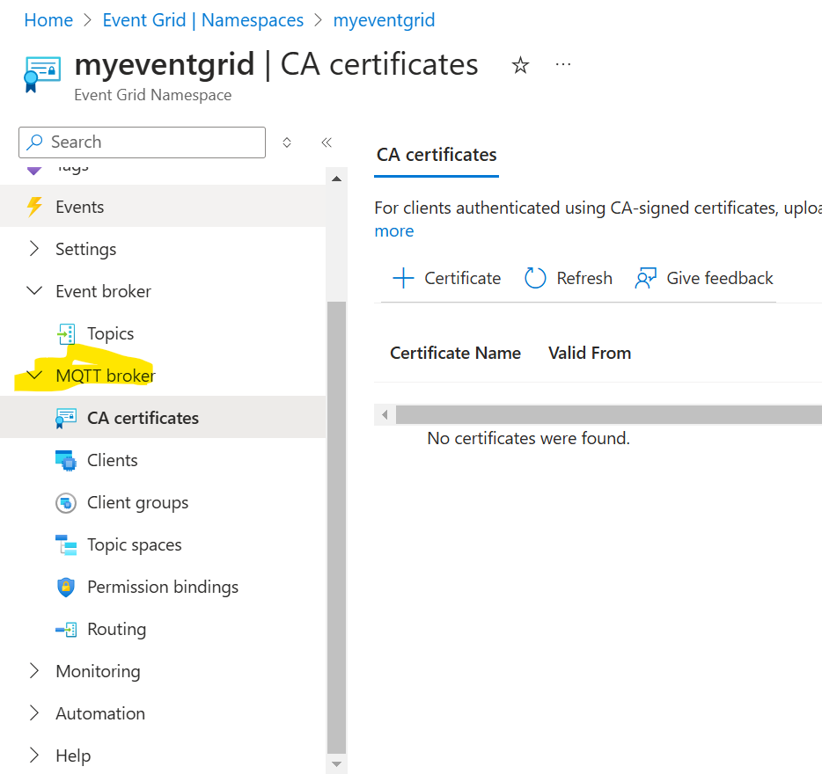Example: Forwarding a temperature alert to a monitoring dashboard.